Advanced Database Training
2026
Vaishnavi Kamthe

Assignment 5

Question
Import data from dim_students.csv file into a table with the name “dim_students”.
Alter the table dim_students to include 3 columns “valid_from”, “valid_to” of date data type, and “is_active” of Boolean/tinyint data type. Update the table dim_students, to set the below values for all the rows
● valid_from = today’s date
● valid_to = ‘9999-12-31’
● is_active = 1
UPDATE dim_students
SET
valid_from = CURDATE(),
valid_to = '9999-12-31',
is_active = 1;
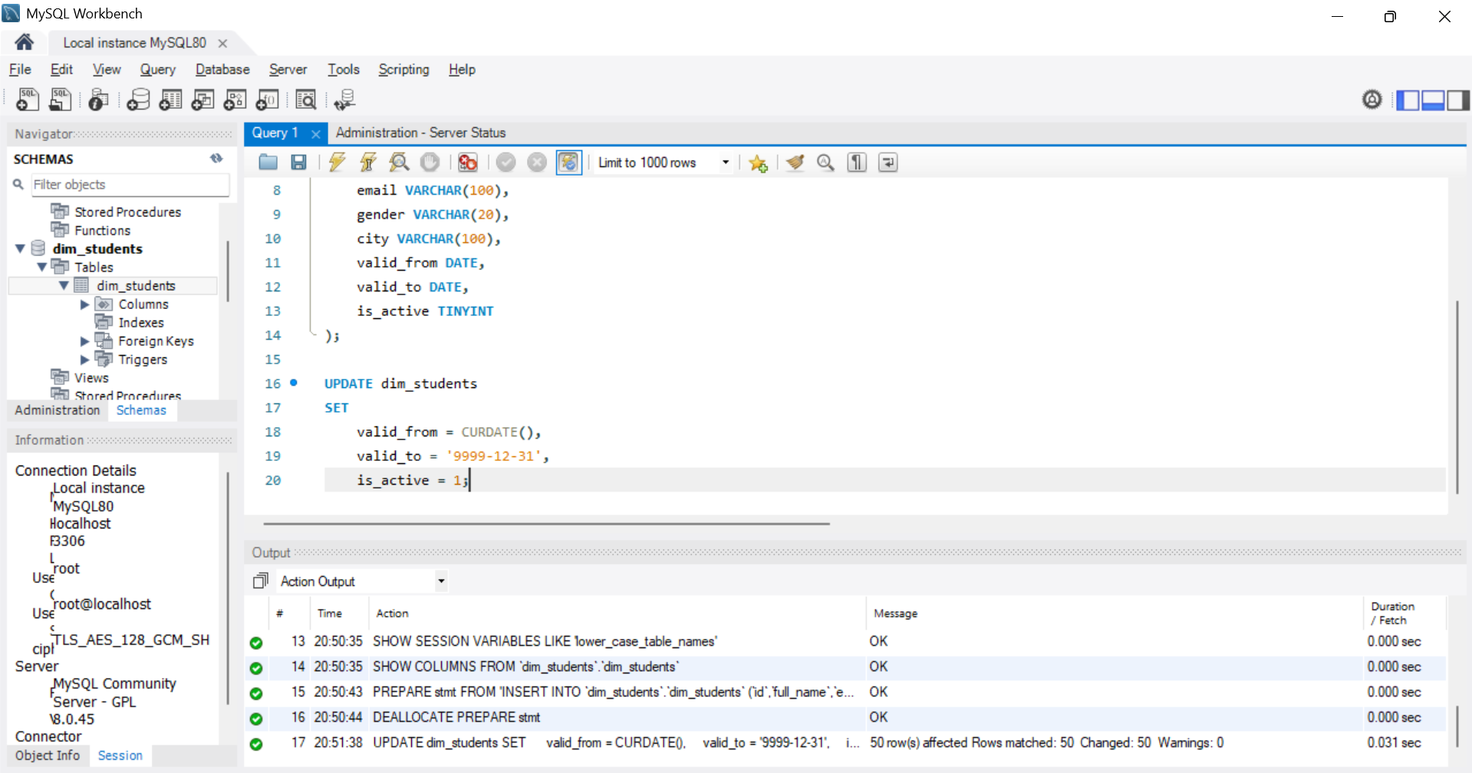
After the above steps, your dim_students table should look like the below:
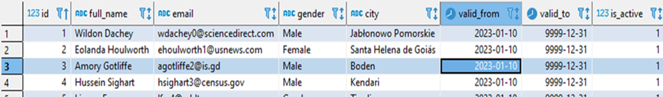
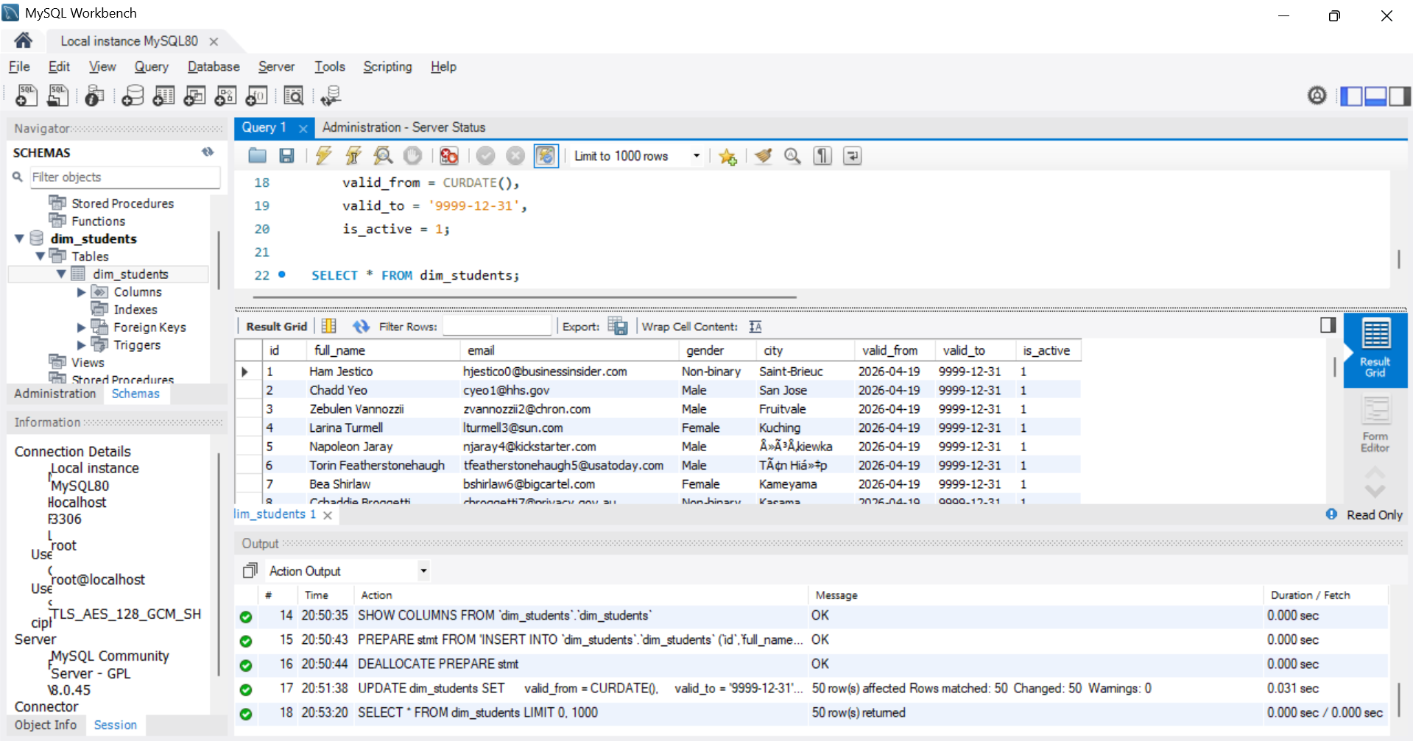
Now import the stg_students.csv file into a table with the name “stg_students”.
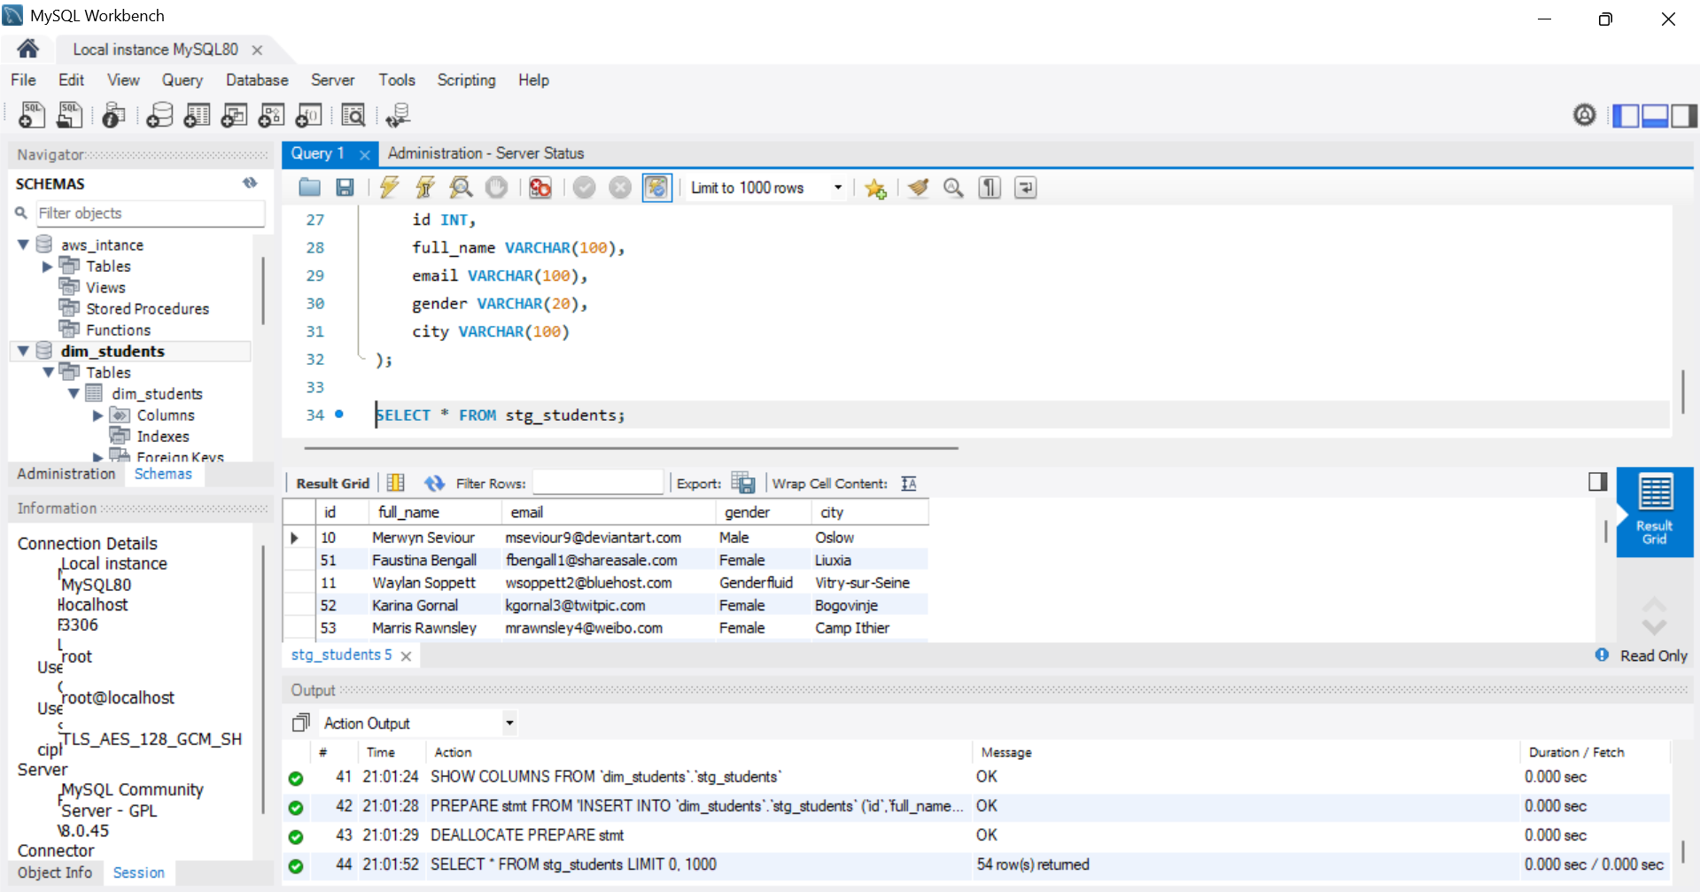
Now create a stored procedure to perform the SCD2 operation on the dim_students table such that it will take data from stg_students table and will insert and update in dim_students table.
The procedure should handle below cases as part of SCD2:
● Insert the new records in dim_students table, and mark
○ valid_from = today’s date
○ valid_to = ‘9999-12-31’
○ is_active = 1
● Update the existing records in dim_students table to set
○ valid_to = today’s date
○ is_active = 0
● Insert the changed records in dim_students table, and mark
○ valid_from = today’s date
○ valid_to = ‘9999-12-31’
○ is_active = 1
DELIMITER $$
CREATE PROCEDURE scd2_students()
BEGIN
UPDATE dim_students d
JOIN stg_students s
ON d.id = s.id
SET
d.valid_to = CURDATE(),
d.is_active = 0
WHERE d.is_active = 1
AND (
d.full_name <> s.full_name OR
d.email <> s.email OR
d.gender <> s.gender OR
d.city <> s.city
);
INSERT INTO dim_students (id, full_name, email, gender, city, valid_from, valid_to, is_active)
SELECT
s.id,
s.full_name,
s.email,
s.gender,
s.city,
CURDATE(),
'9999-12-31',
1
FROM stg_students s
LEFT JOIN dim_students d
ON s.id = d.id AND d.is_active = 1
WHERE d.id IS NULL
OR (
d.full_name <> s.full_name OR
d.email <> s.email OR
d.gender <> s.gender OR
d.city <> s.city
);
END $$
DELIMITER ;
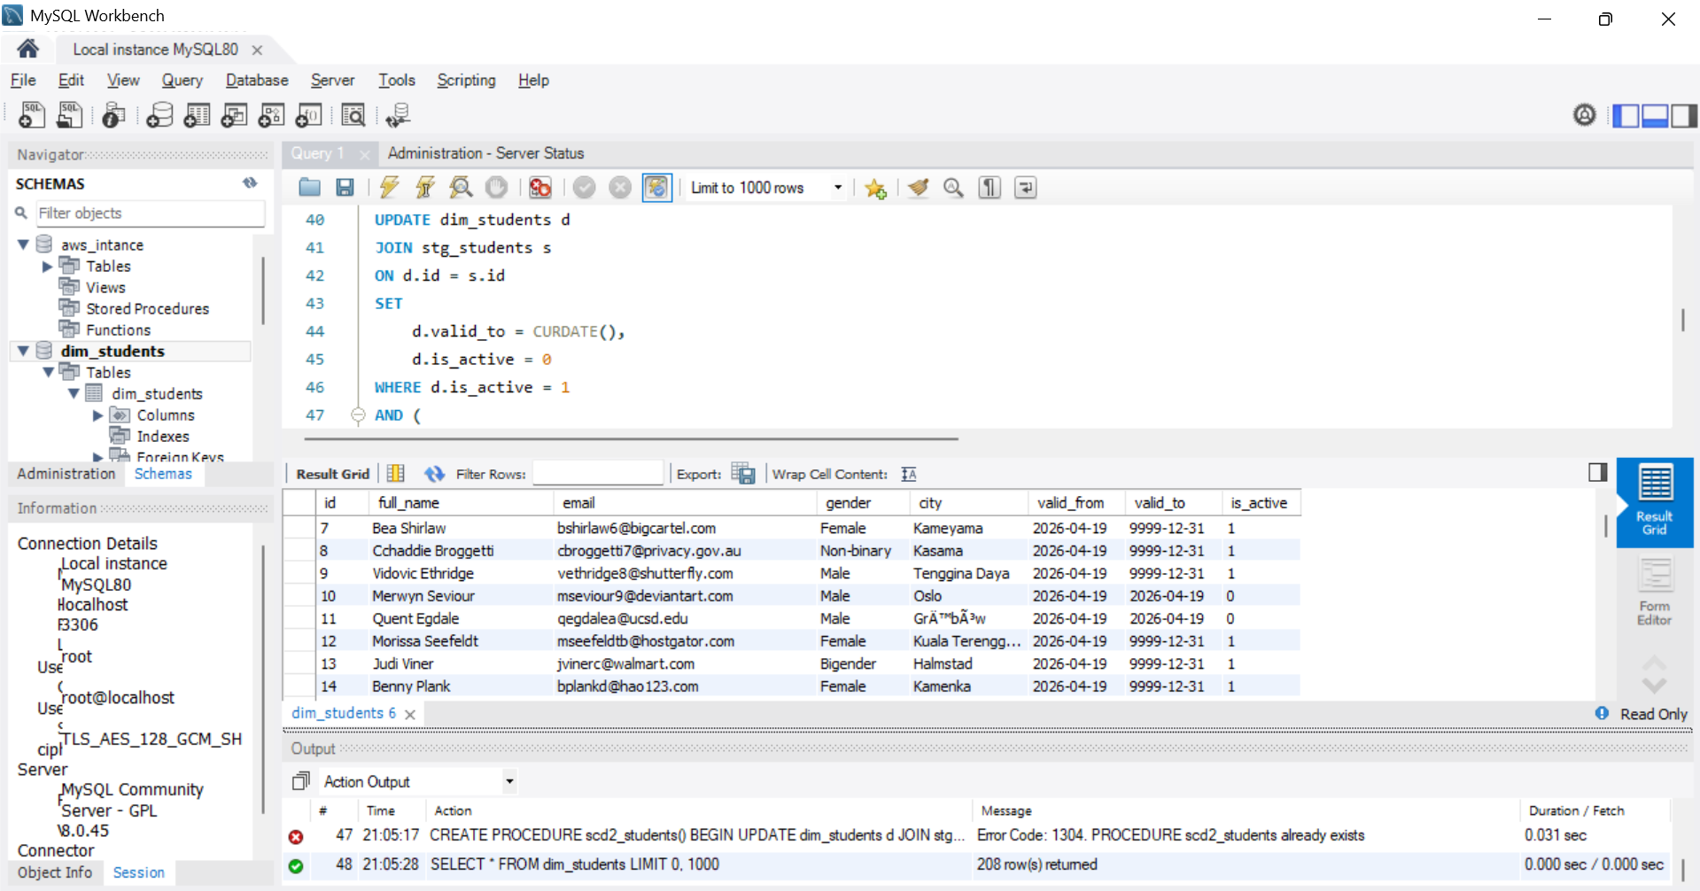
After all the above operations, your final data in dim_students table should look like: